TERMS OF REFERENCE (TOR)

For

**Integrated Digital Service Delivery Platform for**

**Ministry of Health and Family Welfare**

**COMPONENT: 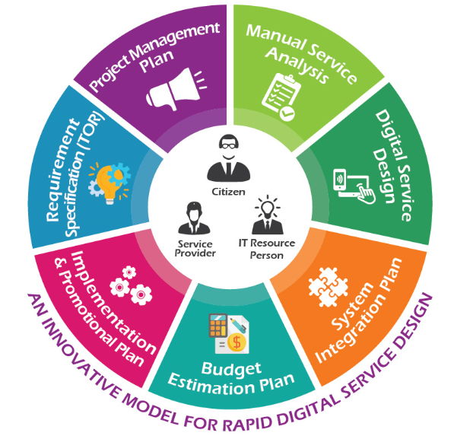 Clinical Trial Management System**



**Prepared By**

Ministry of Health Services

19th Digital Service Design Lab (DSDL)

(9th Ministry/Division)

**Venue:** National Agriculture Training Academy (NATA), Gazipur.

**Date**: 23-28 April, 2019

**Organized By:** Ministry of Agriculture & a2i, ICT Division

**Supported By**

Access to Information (a2i) Programme, Information & Communication Technology Division (ICTD)

**Advised by:**

|  |  |  |  |  |
| --- | --- | --- | --- | --- |
| **Name** | **Designation** | **Ministry/Division/ Organization** | **Phone/Mobile No.** | **Email** |
| Md. Nasiruzzaman | Secretary | Ministry of Agriculture | 9540100 | secretary@moa.gov.bd |

**Designed & Planned by:**

Service Provider (Participants)

|  |  |  |  |  |
| --- | --- | --- | --- | --- |
| **Name** | **Designation** | **Ministry/Division/**  **Organization** | **Mobile No.** | **Email** |
| Md Ayub Hossain | Assistant Director | DGDA | +8801711670282 | ayub64hossain@gmail.com |
| Dr. **Aysha Siddiqua** | Pharmacologist | DGDA | +8801741179128 | askolpona@gmail.com |
| Md. Mohid Islam | Superintendent of Drugs | DGDA | +8801708506060 | mdmuhidislam@gmail.com |

Service Recipient (Citizens)

|  |  |  |  |  |
| --- | --- | --- | --- | --- |
| **Name** | **Designation** | **Organization** | **Mobile No.** | **Email** |
| Dr Tawfiqur Rahman Bhuyan | Scientist | Icddrb | 01713186952 | tawfiqur@icddrb.org |
| Dr Md Mozha | Recearch Investigator | Icddrb | 01911722007 | mazharul.zia@icddrb.org |

Technical Advisory, Design & Planning Assistance by:

|  |  |  |  |  |
| --- | --- | --- | --- | --- |
| **Name** | **Designation** | **Ministry/Division/ Organization** | **Mobile No.** | **Email** |
| Forhad Zahid Shaikh | Chief Strategist | a2i, ICT Division | 01711618368 | [forhad.zahid@a2i.gov.bd](mailto:forhad.zahid@a2i.gov.bd) |
| Md. Hamidul Islam Prodhan | National Consultant | a2i, ICT Division | 01710824401 | hamidul.islam@a2i.gov.bd |
| Irfan A Khan | National Consultant | a2i, ICT Division | 01711346407 | irfan.khan@a2i.gov.bd |
| S M Shihab PErvez | IT Resource Person | a2i, ICT Division | 01985889470 | shihabicicle@gmail.com |
| Md. Mahbubur Rahman | Assistant Programmer | a2i, ICT Division | 01794000011 | mahbub.ntr@gmail.com |
| Ashiqul Aziz Shaikh | Deputy Coordinator | a2i, ICT Division | 01730717482 | ashiquee.bd@gmail.com |
| Md. Abdullah Al Rayhan | Junior Consultant | a2i, ICT Division | 01673548485 | md.rayhan@a2i.gov.bd |
| Md. Nazmus Sakib | Young Professional | a2i, ICT Division | 01973621516 | nazmussakibrubel@gmail.com |

**Table of Contents**

1. Background 4

2. Review of Existing Services 4

2.1 About the Organization 4

2.2 Existing Services (As-Is) 6

2.3 Problems and Challenges 12

3. Proposed Digital Service (To-Be) 14

3.1 Digital Service Objectives 14

3.2 Digital Service Scope 15

4. Digital Service Functional Requirements 16

4.1 Solution Architecture 16

4.2 Digital Service Functions and Features 16

4.3 Users and User Roles 38

4.4 Security and Privacy Requirements 39

4.5 Integration Requirements 41

4.6 Hosting Requirements 44

5. Digital Service Non-Functional Requirements 44

5.1 Application Compliance Requirements 44

5.2 Sizing, Performance and Scalability Requirements 44

5.3 Business Continuity 45

5.4 Interoperability and Data Exchange 45

5.5 System Audit 46

5.6 UI/UX. 46

5.7 Language Support 46

5.8 Accessibility 46

5.9 Coding Conventions 50

5.10 Documentation 50

5.11 Tools and Technologies to be used 50

5.12 Quality Attributes and Assurance 51

5.13 Copyright 51

6. Scope of Work 52

6.1 Development and Implementation Methodology 52

6.2 System Requirement Analysis 52

6.3 System Design 52

6.4 Development 53

6.5 Integration 53

6.6 Testing 53

6.7 Hosting 54

6.8 User Acceptance Test (UAT) 54

6.9 Management and Migration of Legacy Data 54

6.10 Deployment and Implementation 54

6.11 Training and Knowledge Transfer 55

6.12 Duration of the Project and Work Station 55

6.13 Maintenance and Support Service 55

6.14 Work Distribution and Team Composition 56

6.15 Expected Deliverables 57

7. TCV Analysis and Budget 57

7.1 TCV analysis 57

7.2 Software Development Budget 59

7.3 Pilot Implementation Budget 62

8. Conclusion 64

## Background

Technologically transforming the country into “Digital Bangladesh” by 2021 is the vision of Government of the Peoples' Republic of Bangladesh in the arena of Information and Communication Technology (ICT). The government has also put a special importance on ICT as an instrument for national development and sustainability.

As part of this vision, government is in the process of making available of all government services digitally at the doorsteps of all levels of citizen’s in the form of Digital Service. It will add value to ensure transparency, accountability and human rights through extreme use of technology. In addition, it will improve the daily lifestyle of all classes of people.

Currently Citizens’ access to government services has limitations in terms of quality services and emergency responses from the agencies involved. As the outcome of such projects, people will enjoy quick and speedy delivery of services including education, healthcare, infrastructure, utilities, law enforcement, etc. with minimal cost, time and hassle.

Ministry of Agriculture is going to introduce delivery of following Digital Service s to citizens of this service/project:

* License, Registration, Clearance & Certification Management System
* Agri Research, Testing, Report & Data Repository Service
* Incentive & Grant Management System (Allowance, Incentive & Grant)
* Agri marketing & Business Linkage Management System
* Market Infrastructure & Warehouse Management System
* Virtual Crop Pest Museum
* Crop, Seed, Germplasm & Fertilizer Production, Development, Distribution & Service Management System
* Irrigation & Scheme Management System
* Training, e-Learning & Venue Management
* Agri, SIF & Existing System Analysis (Agri Portal, SIF & Existing System of Ministry and its Department)

Identified Digital Service s will reduce the number of steps and levels involved and limit the options for corruption dramatically, making service delivery more transparent and accountable through ‘one-stop’ service delivery centers.

## Review of Existing Services

### About the Organization

DGDA provides services pertaining to medicinal products, medical devices , Traditional , Alternative and homeopathic medicinal products in accordance with the Existing Laws legislation of the Government of the peoples Republic of Bangladesh. Regulatory systems play a key role in assuring the quality, safety, and efficacy of medical products. Effective regulatory systems are an essential component of health systems and contribute to desired public health outcomes and innovation.

The Directorate General of Drug Administration under the Ministry of Health & Family Welfare (Health Service Department), Government of the People's Republic of Bangladesh is the Drug Regulatory Authority of the country. This agency supervises and implements all prevailing Drug Regulations in the country and regulates all activities related to import, procurement of raw and packing materials, production and import of finished drugs, export, sale, pricing, etc. of all kinds of medicine and medical devices including Ayurvedic, Unani, Herbal and Homoeopathic system of medicine.

At present, there are 269 Allopathic, 206 Ayurvedic, 266 Unani, 32 Herbal and 79 Homeopathic drug manufacturing companies in the country. The Directorate General of Drug Administration monitors and regulates all the activities of these 852 companies. The chief of the Directorate is designated as the Director General. He is also empowered by the Govt. to act as the Licensing Authority (drugs) for the purpose of issuing licenses to manufacture, store, sell, import and export drugs and medical devices.

At present, there are 55 district offices of the Directorate in the country. All officers of the Directorate function as "Drug Inspector" in pursuant to the Drug Laws and assist the Licensing Authority for proper discharging of his responsibilities. Besides, a number of Committees, such as Drug Control Committee (DCC), Standing Committee for procurement and import of raw materials and finished drugs, Pricing Committee and a number of other relevant Committees, which comprise of experts, are there to advise the Licensing Authority and to recommend to him matters related to drugs and medicines. DGDA is engaged diligently to ensure the sustainable development through implementation of policies adopted by the government for to achieve middle income status of the nation as per development goal 2021.

Comparing with global Stringent National Regulatory Authorities (NRAs) DGDA have the legal mandate ( The Bengal Drugs Rules 1946 ............and formulated GCP Guideline in recent times )

to authorize regulate and, if necessary, terminate clinical trials (CTs) which is being initiated since 2018. The necessary requirements, guidelines, procedures and forms are being well developed and experiencing frequent revisions to be in line with country and region-specific guidelines as well as major international CT guidance including guidelines from the Declaration of Helsinki, the Nuremberg code, International Council on Harmonization, and World Health Organization Good Clinical Practices. CT oversight is aimed at protecting the safety and rights of humans participating in CTs, ensuring that trials are adequately designed to meet scientifically sound objectives, and preventing any potential fraud and falsification of data.

NRAs are responsible at two stages for the critical evaluation of the documentation supporting clinical studies: when CTs (Protocol) are being proposed for authorization and when the results are submitted in an application for marketing authorization. CT protocols should be reviewed and approved by Independent Ethics Committees before the trial commences. A CT review committee should review the protocols and should have the authority, when necessary, to require protocol revisions. The CT Advisory committee composed of 12 members who have the appropriate medical and scientific knowledge, experience and skills and who are free of conflicts of interest.

In order to ensure the quality and safety of investigational products, the investigational products should be manufactured in compliance with Good Manufacturing Practices for investigational medical products, and the supporting preclinical studies should be in compliance with Good Laboratory and Clinical Practices. Additionally, the importation, storage, use, and/or destruction of investigational products should follow requirements depicted in the applicable laws and legislations followed by DGDA . Qualified and experienced inspectors should carry out on-site inspections of the CT sites to verify compliance with Good Clinical Practices, ethical principles and regulatory requirements, and to provide assurance of the quality and reliability of the data obtained. The oversight activities should be conducted with due concern for confidentiality and integrity.

The legal provisions should allow the NRA to recognize and/or rely on relevant CT decisions, reports and information from other NRAs or from designated regional and international bodies. In special circumstances (e.g., for public health interest), the legal provisions should allow the NRA to elect not to follow the routine CT procedures. Transparency in the entire oversight process is fundamental to ensuring the safety of patients and to ensuring that no product with unacceptable benefit to risk balance will be made available to the public.

### Existing Services (As-Is)

#### Existing Service Delivery &Beneficiary Information

|  |  |  |  |
| --- | --- | --- | --- |
| ***Existing Service Delivery & Beneficiary Information*** | | | |
| ***Service Name: Clinical Trial Oversight Service*** | | | |
| ***Organization Name: DGDA*** | | | |
| **No. of Service Delivery Offices** | **No. of Service Delivery Users** | **No. of Benificiaries** | **No. of Service Delivery (Monthy/Quarterly/Yearly)** |
| 1 | 4 | 30 | 30(Yearly) |

#### Existing Service Process diagram (Service Recipient)

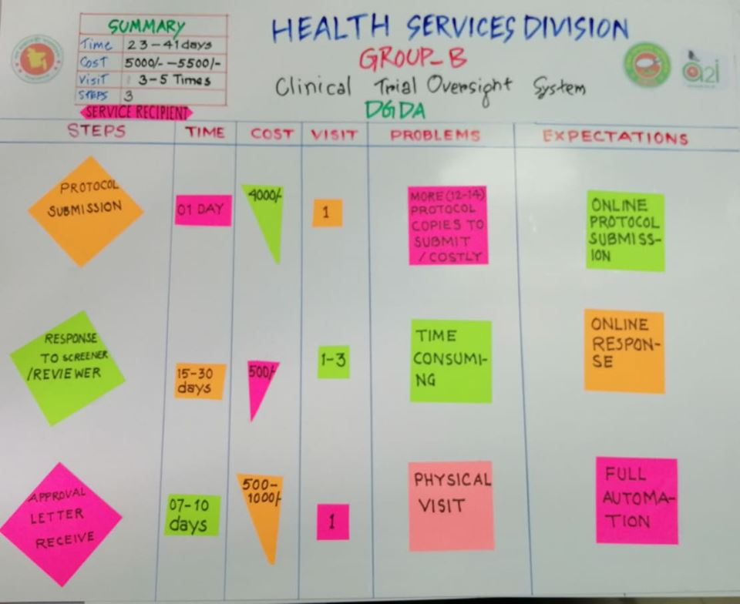

Fig. No.:01

#### Existing Service Process diagram (Service Provider)

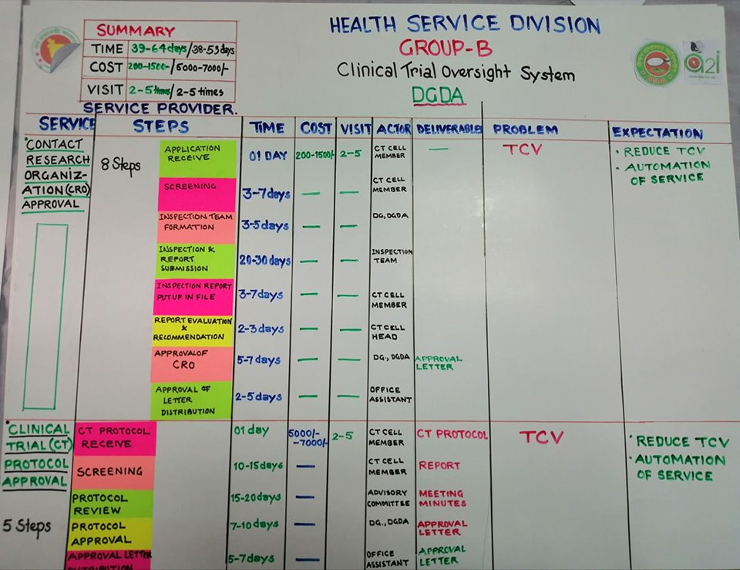

Fig. No.:02

#### Existing Services Process Analysis (ESPA)

|  |  |  |  |  |  |  |  |  |
| --- | --- | --- | --- | --- | --- | --- | --- | --- |
| **Existing Service Process Analysis** | | | | | | | | |
| **Ministry/ Division Name: Directorate General Of Drug Administration** | | | | | | | | |
| **Group Name: B** | | | | | | | | |
| **Service Name: Clinical Trial Oversight Service** | | | | | | | | |
| **SL** | **S.Id.** | **Steps** | **Action** | **Document Name, Action (receive dispatch save )** | **Actor** | **Deliverables** | **Problems** |
| **1** |  | **Protocol Recieved** |  |  |  |  |  |
| **2** |  |  | Protocol recieved | 12 Copies Protocol received | Receive Section | Application/ copies protocol receive note | **Increased T C V** |
| **8** |  |  | Docketed protocol sent to CT head for screening | protocol placed before CT head | CT Head | Application Type Categorization |  |
| **7** |  | **Screening** |  |  |  |  |  |
| **9** |  |  | CT Head assigned Screener | Application/protocol | CT Cell Member | Screener Assigned |  |
| **10** |  |  | Screeners primary screening | Application/protocol | CT Cell Member | Primary Screening Completed | T C V |
| **11** |  |  | report / Observation summarized | Application/protocol | CT Cell Member | Screening Report/Deficiency Notification | T C V |
| **12** |  |  | Summarized report sent to CT Head f |  |  |  |  |
| **14** |  | **Protocol Review committee meeting** |  |  |  |  |  |
| **15** |  |  | Communication with review committee member | Availability of Dates | CT Cell Member | Meeting Scheduled |  |
| **16** |  |  | proposed meeting Date Availability | Draft Scheduled Date | CT Cell Member | Finalized Meeting Date |  |
| **18** |  |  | letter preparation |  | CT Cell Member | Meeting Minutes |  |
| **19** |  |  | Notification |  | CT Cell Member | Meeting Minutes |  |
| **20** |  |  | Meeting Held |  | CT Advisory Committee Member | Meeting Minutes |  |
| **21** |  |  | **Meeting minutes** |  | CT Cell Member | **Meeting Minutes** |  |
| **22** |  |  | Meeting Minutes Send to Advisory committee |  | CT Cell Member and Review committe member | Signed Meeting Minutes |  |
| **24** |  | **Approval** |  |  |  |  |  |
| **25** |  |  | Approval letter preparation |  | CT Head | Approved letter |  |
| **26** |  |  | CT Head received Recommendation for Approval |  | CT Cell Member | Approved letter |  |
| **27** |  |  | Letter signed |  | DG | Approved letter |  |
| **28** |  |  | letter sent to Dispatch for distribution |  | Dispatch | Approved letter |  |
| **32** |  | **Distribution** |  |  |  |  |  |
| **33** |  |  | Dispatch received signed letterhead |  | Dispatch | Memo enveloped |  |
| **34** |  |  | Scanned and email |  | Dispatch | Printout of mailing list |  |
| **41** |  | **CRO** |  |  |  |  |  |
|  |  | **CRO Application Received** | Application received |  | Despatch |  |  |
|  |  |  | Docketed and sent to CT head for Assigning screener |  | CT Head |  |  |
|  |  | **Screening** |  |  |  |  |  |
|  |  |  | CT Head assigned Screener | Application submitted | CT Head |  |  |
|  |  |  | Screeners primary screening as per checklist | Application Screening | CT Member |  |  |
|  |  |  | report / Observation summarized | A/ NA/RA listed | CT Member |  |  |
|  |  |  | Summarized report sent to CT Head | Screening Report | CT Head |  |  |
|  |  | Inspection Team Formation |  |  |  |  |  |
|  |  |  | Summarised Report placed before DG for inspection team formation | Communication with review committee member | CT Head |  |  |
|  |  |  | DG Nominates Team Member | proposed meeting Date Availability | CT Member |  |  |
|  |  |  | Inspection Letter prepared and signed | letter preparation | CT Member |  |  |
|  |  |  | Notification sent to team members | Notification | Inspection Team member |  |  |
|  |  | Inspection |  |  |  |  |  |
|  |  |  | Inspection Team member communicate with applicant |  | Inspection Team member |  |  |
|  |  |  | Finalize Inspection Date | *letter preparation* | Inspection Team member |  |  |
|  |  |  | Notified all team members | *Letter signed* | Inspection Team member |  |  |
|  |  |  | pre inspection meeting | *letter sent to Dispatch for distribution* | Inspection Team member |  |  |
|  |  |  | on site audit as per SOP/GCP | *Audit Trial Site* | Inspection Team member |  |  |
|  |  |  | observation Summary | Deficiency/Recommendation lists | Inspection Team member |  |  |
|  |  |  | Shared with Applicant | Closing Meeting | Inspection Team member |  |  |
|  |  |  | report preparation | Draft Report | Inspection Team member |  |  |
|  |  |  | report submission | Final Report | Inspection Team member |  |  |
|  |  | **Inspection Report put up** |  |  |  |  |  |
|  |  |  | Report reviewed by CT Head | Proposal for Approval |  |  |  |
|  |  |  | Proposed for decision and sent to dg | Letter Signed |  |  |  |
|  |  | **Approval** |  |  |  |  |  |
|  |  |  | CT Head received signed letterhead | official Memo |  |  |  |
|  |  |  | sent to CT Member for Notifying Applicants CAPA submission | Memo |  |  |  |
|  |  |  | *letter sent to Dispatch for distribution* | Memo | Dispatch /CT Member |  |  |
|  |  | **Distribution** | Dispatch received signed letterhead | Memo | Dispatch |  |  |
|  |  |  | Enveloped and stamped | Memo to Specific Applicant | Dispatch |  |  |

**Problems and Challenges:**

|  |  |  |  |
| --- | --- | --- | --- |
| **Service Name: Clinical Trial Service** | | | |
| **Organization Name: Directorate General of Drug Administration** | | | |
| **Citizen existing Challenges VS Possible Benefits** | | | |
| **Service Recipient** | **SL** | **Existing Challenges** | **Possible Benefits** |
| **1** | To collect information service recipient has to go from desk to desk of different offices and departments. | The proposed system will have detail information of all the services as well as service wise prerequisite checklist |
| **2** | To receive any service, Service Recipients have to visit physically | There will be provision in the new proposed system, where service recipients will be able to apply online for all types of services without harassment and unnecessary delay through web and mobile application |
| **3** | Service Recipients can not provide feedback, queries, suggestions, opinion or complain easily | The proposed system will have option for Service Recipients to submit feedback, queries, suggestions, opinion or complain easily through web and mobile app. Service recipient will also be able to track status of their feedback, queries, suggestions, opinion or complain. |
| **4** | There is no option for service recipient to know the status of his/her application | Service recipient will get notification of his/her application through SMS, Mobile App and also login to the system and find out the status of his/her application through service tracker |
| **5** | There is a along waiting period for service recipient for the grant to be approved | The proposed system will reduce the long waiting period from months to days |
| **6** | Service recipient has to travel relevant office to collect the payment | Service recipient will not need to visit any office for payment collection. All payment will be made online through online payment to service recipient account |
|  | **SL** | **Existing Challenges** | **Possible Benefits** |
| **Service Provider** | **1** | Lack of help desk or enough human resources to serve service recipients with information | The proposed system will have detail information of all the services as well as service wise prerequisite checklist |
| **2** | Service provider has to prepare all the letter, note, instruction and necessary documents manually | The proposed System will have option to prepare and generate all required documents in defined format which will reduce significant clerical job hour of Service Providers. |
| **3** | Lack of integration among different organizations of GOB | When implemented & integrated with other GOB organizations through e-Nothi information will traverse among the organizations seamlessly which will increase efficiency & accuracy. |
| **4** | It is difficult for service provider to receive application and sort them manually. The over all process is time consuming | The proposed system will have provision for online application and sorting option. This will eventually reduce a lot of time and increase efficiency & accuracy. |
| **5** | It is difficult for service provider and high officials to monitor the number of application submit ed, number of application approved, number of application pending and number of application rejected. | There will be a service tracker and service monitoring engine through which service provider and high officials will be able to track status of individual application and monitor the number of applications submitted, number of applications approved, number of applications pending and number of applications rejected. |
| **6** | Due to busy schedule of high officials and Approve authority it is difficult to approve application on time | High Officials and Approve authority can act on application using web and mobile app from anywhere, without attending office. |
| **7** | Service Providers cannot easily communicate with Service Recipients on approval of application | Service recipient will get notification of his/her application through SMS, Mobile App and also login to the system and find out the status of his/her application through service tracker. |
| **8** | It is difficult to issue a lot of GO and cheque for making payment to beneficiary | Service provider will not need to prepare cheque for payment purpose. All payment will be made online through online payment to service recipient account |
| **9** | There is not access to any kind of report such as application list, approved application list, rejected application list, remaining budget report, service performance report, etc. All reports are prepared manually which is very time consuming | There will be a robust reporting engine in the new system through which service provider will be easily able to generate and view all kind of reports in just few clicks through web and mobile app |

## Proposed Digital Service (To-Be)

### Digital Service Objectives

Objective of this initiative is to design, develop and implement a citizen centrist and national impacted Delivery Platform for all to ensure Accountable & Satisfactory Health service with SMART tracking & Monitoring.

#### Service Recipient

* The service recipient objective is, to have online information service delivery platform, Notification and Broadcasting, Email Circulation, primary tools and technique to get all services information through web & mobile apps.
* Reduced Time, Cost and Visit.
* Track own applications.

#### Digital Service Operators (Service Provider)

* Provide tools and technique for managing all Process in an organized manner.
* To ensure timely services in a transparent manner.
* To automate all official work related.
* Eliminate Clerical activities in the process

#### Digital Service Observer (Service Performance Monitoring Authorities)

* To monitor all of the Organizations of MoHFA and as well as all Service Recipients and Providers also.
* Demographic Analysis of Service Recipients.

### Digital Service Scope

#### Service Recipient

* From this Platform, Service Recipient will be able to view all types of available services as well as service wise prerequisite checklist.
* Service Recipients will apply online for all types of services without harassment and unnecessary delay.
* Through this system, Service Recipients will be able to submit Appeals, queries, suggestions, opinions or complains easily & system will notify of mitigation status & actions taken.
* Service Recipients will get notification on latest status of her application. they can also log in to the system to know of next step, authority, expected delivery date etc.

#### Digital Service Operators (Service Provider)

* System will prepare all required documents in defined format which will reduced significant clerical job hour of Service Providers.
* When implemented & integrated with other GOB organizations through e-Nothi information will traverse among the organizations seamlessly which will increase efficiency & accuracy.
* Through this online system, Service Providers will easily communicate with each other & be able to share & view calendar to set schedule efficiently
* System will generate e-License or Certificates which will eliminate printing options.
* Through this system, Service Providers will easily communicate with Service Recipients, which will ensure better, efficient & effective service
* Seamless integration with payment gateway will eliminate all hassles of lengthy banking channels.
* Archiving & searching facilities will make searching easy which will ensure better decision making

#### Digital Service Observer (Service Performance Monitoring Authorities)

* With Service monitoring dashboards Service providers' Monitoring authority will be able to make decisions efficiently
* Approval authority can act of application with mobile app from anywhere, without attending office.

## Digital Service Functional Requirements

### Solution Architecture

Solution architecture is expected to define and describe an architecture of the proposed Digital Service Solution in the context of the mentioned prevailing service delivery process i.e. Integrated Digital Service Delivery Platform for Ministry of Agriculture. The solution architecture should assist in the translation of the service to Digital Service transformation requirements into a solution vision, high-level operations and/or ICT application specifications and a portfolio of implementation scope. The expected architecture of a solution, where the solution is a Digital Service system that should offers a coherent set of functionalists to its environment. As such, it should concerns those properties of a solution that are necessary and should be sufficient to meet its essential requirements. The vendor shall propose comprehensive solution architecture on Integrated Digital Service Delivery Platform for Ministry of Agriculture which may cover the following items in their descriptive and diagrammatic presentation

* Goals/Results
* Service Recipients
* Digital Service Operators/User (Service Providers)
* Digital Service Observers (Service Administration and Performance Monitor)
* Database application components:
* Entity application component:
* Utility component
* System federation (Systems to be integrated)
* Process application component
* Interaction application component
* Application
* Accessible Points
* Networks
* Types or Layers of Service Delivery Points
* Hosting Site

### Digital Service Functions and Features

To reach the ultimate objective of this Digital Service development and implementation of the system may have the following Components with necessary Modules, features and functionalities. However, the selected vendor must perform a detailed requirement study and system analysis and prepare the necessary deliverable.

#### Module and Digital Feature List

1. **Clinical Trial Management system**

* DGDA CRO Information Services
* Online Application
* Online User Registration
* Eligibility Checker
* NID Verification
* UTN number Verification
* Notification
* Application status Tracking
* Dynamic FAQ
* E-Attachment
* E-Payment Gateway
* Dashboard

1. **CRO and Protocol Approval Management System**

* CRO/Protocol Application Checklist-WHO 20 Item Dataset
* Application
* Screening and reviewing Management
* Service Guidelines Configuration
* CRO location finder using Google Map
* Document Screening
* Document Verification
* Primary Report Generation
* CT Advisory Committee Meeting Fixation Calendar
* Report for submit ion
* Notification
* Approval
* Feedback

1. **Inspection Management Systems**

* Inspectors Registration
* Inspection auto Team Formation
* Auto Letter Generation
* e- Schedule Management
* Inspection Team members Role management
* On site Audit summary report upload
* Summary report Sharing
* feedback
* Final report preparation
* Notification
* Dashboard

1. **CRO and Protocol Data Bank**

* Summarized CRO History Report
* Protocol Archive
* Protocol Amendment
* E CRF Archive
* Verified Informed Consent Form
* Update GCP
* Audit Log
* Category Search

#### Digital Features functional flow diagram

#### 

Fig. No.: 3

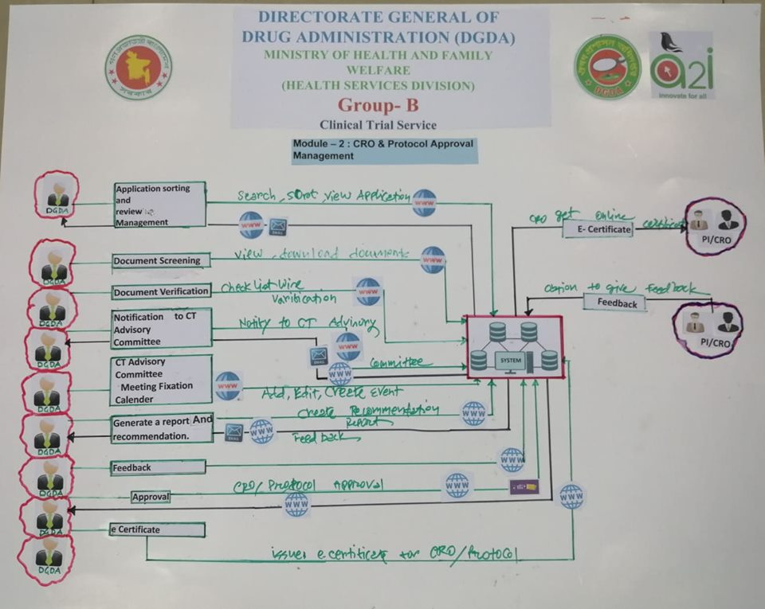

Fig : 4

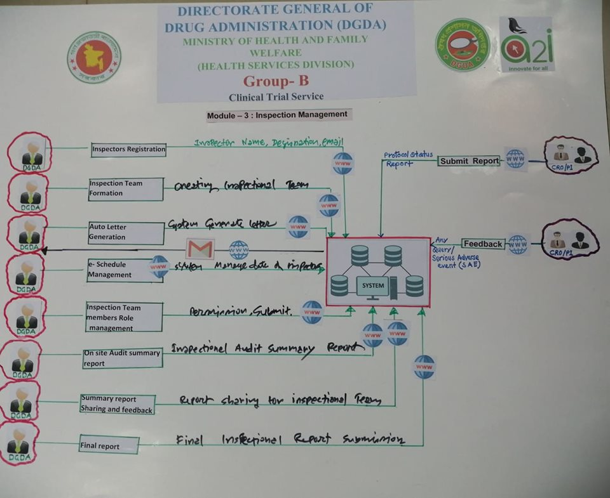

Fig no: 5

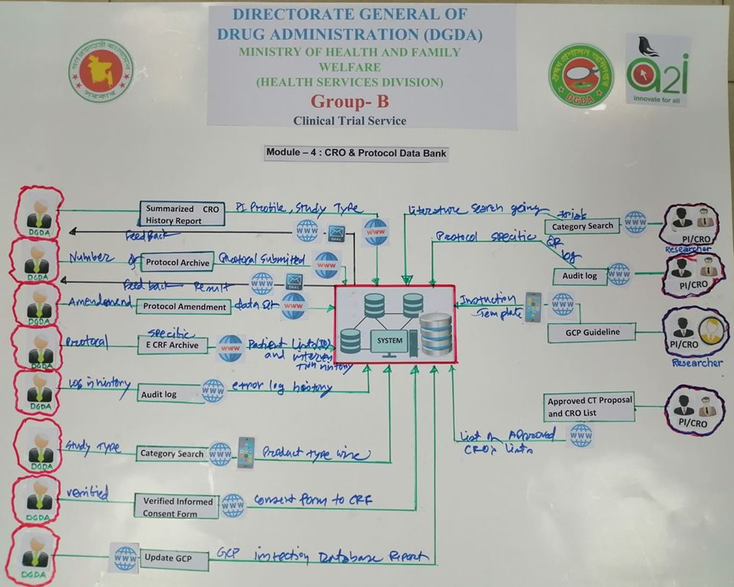

Fig No: 6

#### Component-1: Clinical Trial Management Service

|  |  |  |  |  |  |  |  |  |  |  |
| --- | --- | --- | --- | --- | --- | --- | --- | --- | --- | --- |
| **Digital Service Functional Scope Analysis** | | | | | | | | | | |
| **Organization Name: Directorate General of Drug Administration** | | | | | | | | | | |
| **Component Name: Clinical Trial Management Service** | | | | | | | | | | |
| **e-M Id** | **S Id** | **e-Module** | **e-Feature** | **Actor/User** | **e-Feature Description** | **Time** | **Cost** | **Visit** | **Media** | **Integration** |
| **M1** | S1 | **Clinical Trial Management system** | DGDA CRO Information Services | PI(CRO) | The system will allow the users to search and filter specific topics based on basic search criteria (e.g. CT UTN number, product number, product name, Results ,Study Dates ,Status of Recruitment: Eligibility Criteria MSC Outcome Measure: Sponsor / Collaborator: Exact match Study IDs: Locations: Phase) | 10 MINS | 0 | 0 | Web/App | NA |
|  |  | Online Application | PI (CRO) | Online application through forms/template focused on  A. Screening of subjects, Clinical Examination by Investigator ( Check patient file/Source documents, Subject record and Informed consent, Source Documents and Case Record Form 1 Verify condition, completeness, legibility, accessibility of the investigators source data file. ( source data includes study subject’s files, recording from automated instruments, tracings, X-ray and other films, laboratory notes, photograph negatives, magnetic media, hospital records, clinical and office charts, subject’s diaries, evaluation checklists and pharmacy dispensing records) Quality Assurance –Summary SOP for all procedures conducted at site are available i.e. have a copy of Site Specific and Trial specific SOPs Record keeping and data handling  2 Registered applicants process the application.  5. Validation about existing License Holder or not through user ID | 60 MINS | 0 | 0 | | Web/App |
|  |  | Online User Registration | PI (CRO) | Generate User ID.  NID , Cellphone and Email  Name and Profession* based user of Different types can register | 3 MINS | 0 | 0 | | Web/App |
|  |  | Eligibility Checker | PI (CRO) | The service recipient can Check application and appropriate submission against the stated requirement through this system. System will be providing application status. Technical Validation of application before submission of documents/data  Against WHO /ICMJE Standard Data set and Regulatory Requirements | 5 mins | 0 | 0 | | Web/App |
|  |  | NID Verification | System | NID details and verifications through NID database | 20 SEC | 0 | 0 | | Web/App |
|  |  | UTN number Verification | System | Technical Validation with ICTRP Portal | 10 SEC | 0 | 0 | | Web/App |
|  |  | Notification /Acknowledgement | System | On submission, confirmation, payment the concern will be notify online through Apps, SMS, email etc. Applicant will get notification through SMS/ Email for acknowledgement | 5 SEC | 0 | 0 | | Web/App |
|  |  | Application status Tracking | PI (CRO) | Real time update of Submission status | 3 SEC | 0 | 0 | | Web/App |
|  |  | Dynamic FAQ | PI (CRO) | The User of this service will be able to get Real time response apropos to the generated queries and | 10 SEC | 0 | 0 | | Web/App |
|  |  | List of Authorized CRO | PI (CRO)/DGDA | There will be a list for public viewing | 5 SEC | 0 | 0 | | Web/App |
|  |  | E-Attachment | PI (CRO) | Scanned And web-link based Document processing | 30 SEC | 0 | 0 | | Web/App |
|  |  | E-Payment Gateway | PI (CRO)  Service Recipients/ Service Providers | Payment feature will consist of payment gateway integration tools which will ensure online payment transaction between service recipient and accounts through the proposed system. | 30 minutes | 0 | 0 | | Web/App |
|  |  | Dashboard | Service Providers | There will a dashboard (user role-wise) on summarized and important information for manage reports of diverse nature based on KPI/KRA mend decision making which, can be detail drill down as needed. System will facilitate result reports and time bound disposal followed by Generating trends for analysis and continuous improvement for Service Providers especially for decision takers . | 1 MIN |  |  | | Web/App |
|  |  | CRO Facility Submission Screening and Review | DGDA | DGDA will evaluate the submission lodged by the applicant conducting side by side comparability exercise. | 20 MIN | 0 | 0 | | Web/App |
|  |  | Trial Study Status Report | PI (CRO)/DGDA | System will facilitate summary reports of the lodged submission on yearly/quarterly /monthly basis as well as real time status for both Service Recipient and service providers. | 1 MIN | 0 | 0 | | Web/App |
|  |  | Protocol Configurable Engine | DGDA | System will allow to submit futuristic submission (Total study/establishment qualification plan) for CRO certification/ Protocol Approval | 10 MIN | 0 | 0 | | Web/App |
|  |  | Protocol Data Analyzer | System | System will be capable of Automated KRA/KPI (Predefined ) based comparability exercise for evaluation of the submission and identifying gaps needed to be addressed | 20 SEC | 0 | 0 | | Web/App |
|  |  | Draft Submission | PI (CRO) | System will allow stepwise submission (save and exit , save and continue ) for registered applicants | 30 SEC | 0 | 0 | | Web/App |
|  |  | Final Submission | PI (CRO) | System will allow the registered applicants submission as accepted primarily generating a response if its comply with the checklist. | 10 SEC | 0 | 0 | | Web/App |
| **M2** |  | **CRO and Protocol  Approval Management System** | CRO/Protocol Application  Checklist-WHO 20 Item Dataset | System | Concerned Department Head / Moderator will assign Screener based on initial Automated sorting based on application type selected by applicants and submitted documents | 10 SEC | 0 | 0 | | Web/App |
|  |  | Application Screening and  reviewing Management | DGDA | The Moderator will assign screener and reviewer accordingly using the feature. | 10 SEC | 0 | 0 | | Web/App |
|  |  | Service Guideline Configuration | DGDA | The system will be generating reports of screener and reviewer as per guidance applicable template which will generate automated report for screener and reviewer . | 2 MIN | 0 | 0 | | Web/App |
|  |  | CRO location finder using  Google Map | DGDA | The System will be displaying Approved CRO/TRIAL protocol on goings or happenings | 15 SEC | 0 | 0 | | Web/App |
|  |  | Eligibility Checker | DGDA | The service recipient can Check application and appropriate submission against the stated requirement through this system. System will providing application status. Technical Validation of application before submission of documents/data | 20 SEC | 0 | 0 | | Web/App |
|  |  | Document Screening | DGDA | The system will determine the initial submission status of completion as per the Checklist. | 2 MIN | 0 | 0 | | Web/App |
|  |  | Document Verification | DGDA | The System can Verify the relevant components as per directives of DGDA as mandatory submission (e.g. TR Chalan) and global CT Database e.g. ICTRP portal, REGTRAC . | 1 MIN | 0 | 0 | | Web/App |
|  |  | Primary Report Generation | DGDA | The System will generate automated report based on the Applicants Screeners and reviewers input . | 1 MIN | 0 | 0 | | Web/App |
|  |  | CT Advisory Committee   Meeting Fixation Calender | System | The System log Communication for meeting date fixation , official letter generation and notification to the CT Advisory committee member | 30 SEC | 0 | 0 | | Web/App |
|  |  | Report submission | DGDA | The Meeting Minutes decision Approval will be done using system along with the storage and archival | 20 SEC | 0 | 0 | | Web/App |
|  |  | Notification | System | Approved meeting minutes will be sent to the CT Advisory committee member for their acknowledgement | 10 SEC | 0 | 0 | | Web/App |
|  |  | Approval/Decision | DGDA | The system will be summarizing Screening , Reviewing and CT Advisory committee members decision of the initial Application submitted . | 3 DAYS | 0 | 0 | | Web/App |
|  |  | e Certificate | DGDA | The Initial submission will be awarded auto generated e certificate which are passed / awarded approval decision based on the criteria | 2 MIN | 0 | 0 | | Web/App |
|  |  | Feedback | DGDA/CRO | The system will generate both service recipient and service provider upon the completion of each step followed by the final decision of specific submission . | 10 SEC | 0 | 0 | | Web/App |
|  |  | **Inspection Management Systems** |  |  |  |  |  |  | | Web/App |
| M3 |  |  | Inspectors Registration | DGDA | Generate User ID. Using  NID , Cellphone and Email  Name and KSA based user category of Different types can register . | 2 MIN | 0 | 0 | | Web/App |
|  |  |  | Inspection Team Formation | DGDA | The system will notify the licensing Authority along with Head CT upon completion of any protocol or application requires review . | 2 MIN | 0 | 0 | | Web/App |
|  |  |  | Auto Letter Generation | DGDA | The system will generate Template based inspection team letter notify the approved team members of the inspection team and the applicant | 20 SEC | 0 | 0 | | Web/App |
|  |  |  | e- Schedule Management | DGDA/CRO | The Fixation of on site audit and documents submission dates and the complain as per proposed or planned schedule expected to satisfy the Inspection team letter. | 20 SEC | 0 | 0 | | Web/App |
|  |  |  | Inspection Team members Role  management | DGDA | The Lead Inspector ( mentioned in the letterhead) will appoint a member of that team as communicator and role of others | 2 MIN | 0 | 0 | | Web/App |
|  |  |  | On site Audit summary report  upload template | DGDA | The system will generate a summary report of the closing meeting conducted on the day of site audit which is acknowledged by the applicant audited | 1 MIN | 0 | 0 | | Web/App |
|  |  |  | Summary report Sharing and feedback | DGDA | The System will send the Summary Report to the applicants following a fixed template for CAPA submission | 1 MIN | 0 | 0 | | Web/App |
|  |  |  | Final report preparation as per template | DGDA | The System will generate the final report based on the writing of the team members conducted the on site audit which will be done following the latest template recommended by the WHO ( WHO TRS 1010; Annex 09 Appendix ) | 1 MIN | 0 | 0 | | Web/App |
|  |  |  | Report generations and submission System | DGDA | The system will generate inspection history starting from application to disposal. Inspector can fill in or write his or her observations / recommendation’s as per the pre set template | 30 SEC | 0 | 0 | | Web/App |
|  |  |  | Notification | System | On approval, confirmation, rejection of payment the concern will be notified online through SMS, email etc. | 10 SEC | 0 | 0 | | Web/App |
|  |  |  | Dashboard | DGDA/CRO | Competent authority should be able to monitor all activities on display/printable report  Service recipient and providers (Inspectors- following WHO GBT RI 05/06 ) will be able to see different types of individual reports/ printable report. | 0 | 0 | 0 | | Web/App |
| M4 |  | **CRO and Protocol Data Bank** |  |  |  |  |  |  | |  |
|  |  |  | Summarized CRO History Report | CRO/DGDA | The system will generate KPI Based CRO Summary as per indicated in ICH E6, E17 E 3 . | 10 MIN | 0 | 0 | | Web/App |
|  |  |  | Protocol Archive | DGDA/CRO | KPI Based protocol Archiving through generation of summary of WHO Data set version (Latest ) and the Summary results listed against each application | 5 MIN | 0 | 0 | | Web/App |
|  |  |  | Add Protocol | CRO | Inclusion of protocol . | 1 MIN | 0 | 0 | | Web/App |
|  |  |  | Protocol Amendment | CRO | Revised submission in case of errors or any queries raised by DGDA side for Recommended Action ( RA ) | 2 MIN | 0 | 0 | | Web/App |
|  |  |  | E CRF Archive | DGDA/CRO | protocol specific CRF Records | 2 MIN | 0 | 0 | | Web/App |
|  |  |  | E Doc processing and Update as per Approved protocol | DGDA | Updates generation based on the submission of data of the applicant as per the protocol and the key dates for achieving milestones and deferral to that with reason | 2 MIN | 0 | 0 | | Web/App |
|  |  |  | Validation | DGDA | Validation of the milestones, results, sample and others achieved in terms of protocol submitted | 1 MIN | 0 | 0 | | Web/App |
|  |  |  | Verification of submitted documents | DGDA | Trial registry Dataset relevant . | 10 MIN | 0 | 0 | | Web/App |
|  |  |  | Blocked / Acceptance notification | DGDA | Approval decision summary . | 20 SEC | 0 | 0 | | Web/App |
|  |  |  | Audit log | DGDA | The system will be capable enough to assure Data Integrity Standard Comparable with MHRA or PIC/S PE-0041/3 Standard | 20 SEC | 0 | 0 | | Web/App |
|  |  |  | Category Search | DGDA/CRO | WHO Trial dataset version 1.3.1 based search ability. | 1 MIN | 0 | 0 | | Web/App |

N.B.: The interested vendor must comply all above mentioned modules and features but not require to limit in this list. Apart from this, the interested vendor should analyzed the other scopes which are relevant to the areas covered above and should propose the best possible and comprehensive ICT solutions in there technical proposal. The ultimate modules and futures of the proposed system will be finalized at the requirement study and analysis phase of SDLC based on client’s actual requirement, acceptance and vendor’s best proposal/solutions relevant to the above mentioned area and scope.

### Users and User Roles

The following table gives a general idea / overview of user types and roles. The vendor shall conduct a more detail analysis of types of user and user roles during System Requirements Specification (SRS).

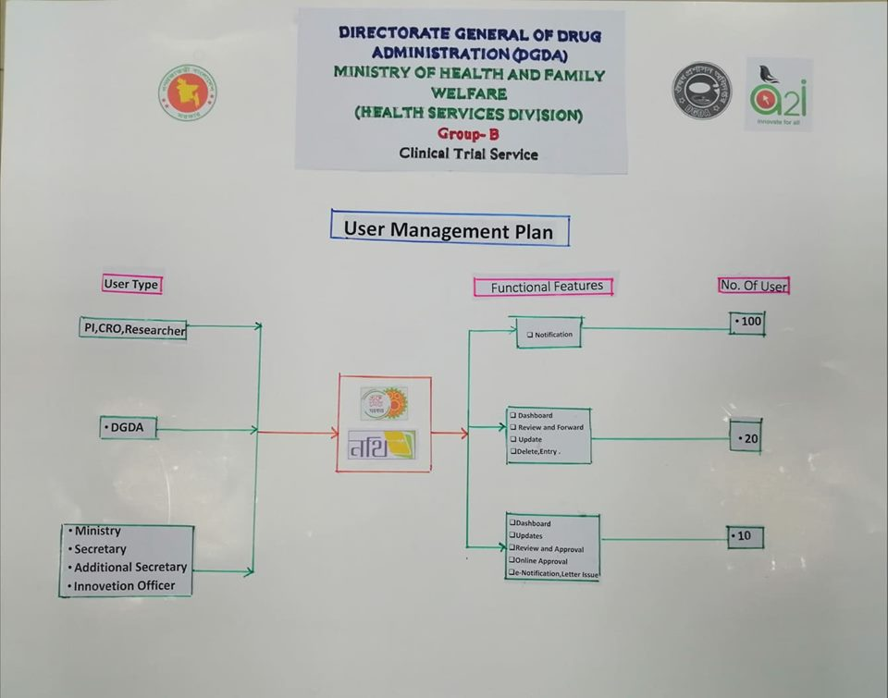

|  |  |  |  |  |  |
| --- | --- | --- | --- | --- | --- |
| Clinical Trial Management Service | | | | | |
| **Directorate General Of Drug Administration** | | | | | |
| **Sl.** | **Type of Users** | **No. of Users** | **No. Of Office/Location** | **User Title** | **User Major Role** | |
| 1 | Digital Service Operator | 30 | 10 | * Upper Division Clerk * IT Officer * Assistant Engineer * Accounts Officer * Convener- Councilor * Executive Officer * Admin Officer | * Information update * Application sorting & verification * Application Approval * Generate e-notification * Profile management * Monitoring Dashboard * Draft circular preparation * View and respond to complain | |
| 2 | Digital Service Administrator | 3 |  | * Executive Engineer * Chairman * CEO | * System admin * User Monitoring * Approval * Administration | |
| 3 | System Administrator |  |  | SA  SSA | * Check data security. * Data accumulation & Processing. * Data backup | |
| 4 | Digital Service Recipients | 5,000 |  | * License & NOC seekers | * Application submission * View Application status | |
| 5 | Digital Service Observer |  |  | * DG | * Give the final approval/comments * Monitoring all activities * Research & policy formulation * Feedback to the government | |

Vendor should submit a comprehensive plan and approach covering different types of users and their roles providing accessibility, privacy, confidentiality and transparency based on the given statics. Also have to mention the user friendliness login system.

### Security and Privacy Requirements

The vendor should submit an extensive and complete security and privacy plan for this Digital Service application considering the following issues

* Project technical scope
* Functional and nonfunctional requirements and ultimate objectives
* Concerned service provider organization’s operational environments and capacity
* User roles - Accessibility, Authorization and Accountability
* Importance of data management
* Technologies to be used for development & run
* Hosting
* Client and service side
* Overall standard application security requirements.

Apart from these, the vendor should keep in account the following considerations also as well as vendor should provide a checklist based on system and hosting security plan (i.e. fraud, hacking, money laundering etc.) & have to provide the test report of that checklist.

**System Security Requirements (But not limited to)**

* The vendor should follow any of the industry standard secure development methodology such as (but not limited to) Comprehensive Lightweight Application Security Process (CLASP) by OWASP etc.
* The vendor should consider (but not limited to) common vulnerabilities such as SQL Injection, Cross Site Scripting (XSS) etc.
* Vendor will undertake responsibility for Input Validation Controls, Authorization/Authentication Control and other security controls in place in both test and production environment of application.
* The following vulnerabilities must be checked and ensured security from the beginning:
  + Cross Site Request Forgery (CRSF)
  + Cross Site Scripting (XSS)
  + Session hi-jacking
  + Session Fixation
  + SQL Injection and Code Injection
  + Input Validation/Filtering
  + Output Escaping
  + Secure File Access
* The vendor shall minimally provide Access control, Authentication and accountability security mechanisms for backend operations of the System.
* The security solution proposed shall be scalable should not affect the performance by creating a bottleneck or single point of failure to the overall system.
* The system should provide tamper-proof audit trails and logs for administrator or auditor to check for the actions committed by users. The audit trails shall consist of following details but not limited to:
  + Login and logout
  + Attempts to access unauthorized resources
  + User profile changes
  + Past audit events.
  + Track all actions performed on documents attached/uploaded.
  + The system should have provision to assign the access rights of other resources on need basis to authorized users.
  + Information in the System that is deemed to be sensitive shall be encrypted and protected from accidental and/or unauthorized modification.
  + The System shall provide automatic session disconnection for inactive user after session time [Proposed best practice session time] is over.

The system shall protect the audit trails from being modified by unauthorized personnel or privileged users.

### Integration Requirements

As a government system or Digital Service application, integration with the required and other prescribed national system is very important and essential. Only by proper integration making interoperable, a Digital Service application can drive the ultimate citizen benefits with the optimum use of technology from service to Digital Service transformation. Here vendor should come up with an integration plan in their technical proposal considering and understanding the scope of the Digital Service application as per this TOR. The possible integration scopes of this Digital Service application are mentioned below as reference for the vendor.

|  |  |  |  |
| --- | --- | --- | --- |
| **No.** | **System Name** | **Purpose** | **Dependent Organization** |
|  | e-Nothi | Document approval process. | a2i, ICTD |
|  | NID | Verify service recipient’s identity | Election Commission |
|  | SMS Gateway | Send and receive SMS | Telecom Operators |
|  | Payment Gateway | Collection & disbursement of payment | MFS and others private gateway provider |
|  | ekPay | Bill Collection | DFS Team, a2i, ICTD |
|  | e-Challan | Bill Collection | DFS Team, a2i, ICTD |
|  | Birth Registration Information Service (BRIS) | Verify Service Recipient’s Identity | LGD |
|  | iBAS++ | Budget allocation and approval process | Finance Division |
|  | Police Clearance Certificate | Verify of police clearance | Bangladesh Police, PHQ |
|  | SSL | Service recipient’s payment | Payment Gateway |
|  | National Portal Framework (NPF) | Published information for recipient | a2i |

**Special Note**: Vendor may get an idea of the integration scope from above table. Exact integration scope will be decided on the SRS (Software Requirement Specification) with confirmation of the client.

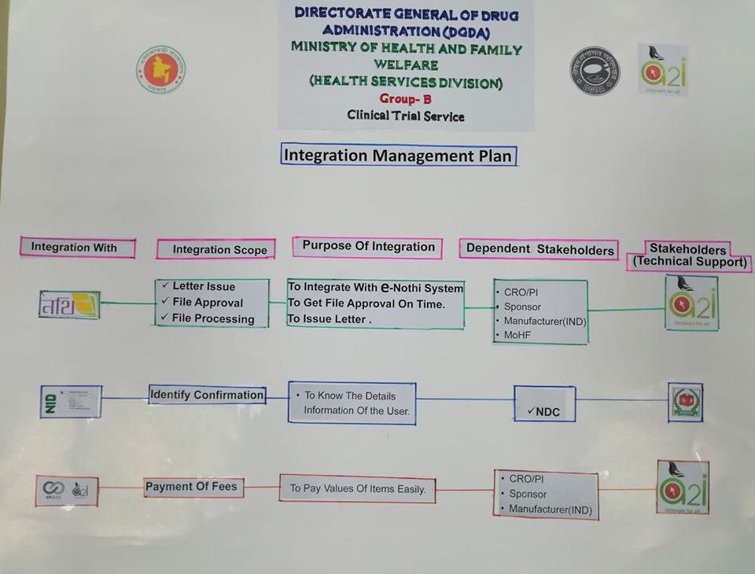

#### Eksheba Sarkar (OISF-Office information and Service framework) integration:

Eksheba Sarkar, developed by a2i, works as a single point of access for Government officers and mediator for various and e-governance solutions. This framework will facilitate various e-governance solutions to share their different services among different e-Governance solutions. Hence redundancy of work will be reduced tremendously.

Any system integrated with Eksheba Sarkar can get then following data, information and shared service-

Data/Information Service:

• Office

• Organogram

• Employee Profile

• Users Information

• Geographical Information

And following shared services can be accessed (not limited to):

• SSO (Single Sign On)

• Approval through E-Nothi

• Grievance submission through GRS (Grievance Redress System)

• Digital Signature

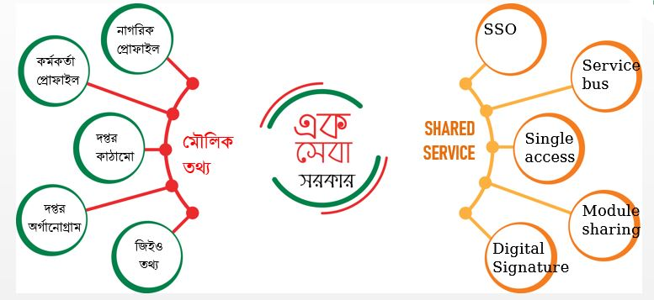

Figure: Eksheba Sarkar

Apart from these, there are some predefined standards described at Eksheba Sarkar. Standards are defined as an established norm or requirement about systems. Eksheba Sarkar works as a mediator of different systems. It connects multiple system and manages communication among them. So to communicate properly and fruitfully some predefined standards need to be followed. Otherwise system to system communication will be in jeopardy. Because of this Eksheba Sarkar is introducing some standards that every e-governance system must follow to Integrate with other systems. To develop any e-governance solution which can communicated other e-government solutions vendor must follow the same standards which is defined under Eksheba Sarkar standard documentation provided by a2i in EKSHEBA Sarkar portal: http://doptor.gov.bd/newportal/.

Those standards are

• Data Standard

• Integration Standard

• Security Standard

• Deployment Standard

• Technology Standard

• Application Standard

• Biometric Standard

• Payment Standard

• Citizen Core Data Standards (CCDS)

**Special note: e-Filing (e-Nothi) integration:**

At different level of activities, the proposed e-Service system may needs to take approval and filing activities at different desks. Hence system has to be integrated with government prescribed e-Filing system (eNothi) through Eksheba Sarkar. Once the proposed e-service system is integrated with eNothi System then at each and every step of decision making the e-Service system will get feedback, decisions and expected output data from the eNothi System.

All communication between the proposed system and eNothi should be through Eksheba Sarkar following the provided standards and guidelines.

### Hosting Requirements

Bangladesh Government is providing an extensive and standard hosting facility for all types of government organization applications and software that is named as National Data Center under Bangladesh computer council (BCC). It may be mentioned here that the vendor developed application will be hosted in government provided data center i.e. National data center (NDC) or Ministry of Agriculture. Therefore, at this stage, vendor is requested to submit a preliminary hosting plan for this Digital Service application considering the issues mentioned below-

* Hosting requirement /environment (hardware, servers, network, security, storage, traffic, firewall, bandwidth etc.)
* Hosting architecture
* Data growth and scalability plan
* User handling/load balancing mechanism
* Licensing issues
* Scheduled backup & restore requirements
* Disaster recovery requirements
* Monitoring tools requirements

## Digital Service Non-Functional Requirements

### Application Compliance Requirements

#### Web Application

* The application which is a web based solution, has to be hosted in a centralized Web-server
* The application should be developed following Service Oriented Architecture (SOA)
* Application should support MVC framework.
* Considering the operating/client environment at different level of this application, it should be developed in such a way so that it requires low bandwidth to run.
* The web-based application should support cross browser platforms (popular web-browsers such Mozilla Firefox, Opera, Chrome, Internet Explorer, Safari etc.)
* Should have ability to seamless integration with future module / components / applications
* Application should be lightweight and rich client-side scripting
* UI should be developed based on the analysis of UX.
* Any web interface of this application should be fully responsive

#### Mobile Application Requirements

* The mobile application version of the system should be developed for Android and iOS.
* The mobile app should have capability of displaying system notifications
* Functionality for registration options for service recipients
* App should enable compact view of services for service recipients.
* There should be an option to auto synchronization with the central database with apps local database on the availability of the Internet connectivity.

### Sizing, Performance and Scalability Requirements

* The system shall be capable of handling online functionalities for a database of at least 1,80,000 service recipients and in terms of service provide 7 and 2100 System Users.
* The system processing shall be scalable to support the **volume estimates for a period of 10 years at a 20% annual growth rate**.
* The system shall be designed to handle estimated 8000/10000 simultaneous connection (online users) when it is ultimately rolled out.
* The vendor must conduct an extensive load testing task taking above factors into consideration and submit a load testing results.
* The database architecture should be such that the system is available to user 24x7x365 days a year without any unapproved downtime.
* Page load time, login response-time, on-click load time for the web application should be less than 3 seconds while this is accessed over the intranet.
* Average transaction response time, on-submit response-time, or any other database access/ search time should be less than 5 seconds when the system solution is accessed over the intranet.
* Considering the network infrastructure challenges in Bangladesh, the solution must support low bandwidth conditions for the services defined in the functional requirements.
* In case of mobile application also, this should support very low bandwidth even in 2G network provided internet bandwidth.
* The proposed solution should be highly scalable to accommodate current and future requirements within the scope of the scope mentioned in the TOR
* Analyze the requirements whether both horizontal scaling (scale-up) and vertical scaling (scale-up) will be required for this Digital Service application or not?
* The Digital Service application should be provided with appropriate caching mechanism to handle very high-traffic scalability
* The vendor may propose here other relevant measures for the Digital Service application scalability.

### Business Continuity

Business Continuity plan will play a very important role by creating the systems of prevention and recovery to deal with potential threats and risk of the Digital Service operation. Vendor is requested to propose a Business Continuity Plan for this Digital Service application. Regarding business continuity you may take in account the followings issues if applicable or suitable for this Digital Service Application

* All standard backup facilities should be supported by the system which can be started with disk-based backup facility, gradually moving to Storage Area Network (SAN) based backup system.
* Data and the Operating system core component will be separated. A ghost image of the Operating system will always be available in case of rebuilding the server. All data can be restored in the data drive once the Operating System is restored.
* System can also have an automated Backup mechanism by which users can schedule the backups and the system will take the backups without manual intervention.
* System must check for the media and generate a report on backup with date time and details of backup.
* If a restoration fails for any reason, the system should prompt with proper error messages and suggest what has to be done to rectify the situation via on-screen, logs, email and text messages.
* System should maintain an automated recovery system and all versions of backup will be maintained. At any given point in time, the versions and incremental backup details can be retrieved from the system.
* The system may be hosted in virtual servers or containers. A restore of a virtual server/container is much easier and faster compared to a single host server.

### Interoperability and Data Exchange

The selected vendor must develop this Digital Service system following all the standards and protocols of interoperability, integration and data exchange with other systems. It is expected that the system will be based on open architecture and will be fully interoperable with the current and future systems.

The following are the key expectations on interoperability requirements:

1. The system should be designed for interoperability using industry standard protocols.
2. System must expose data by Advanced Message Queuing Protocol and REST via TLS
3. All imported data must undergo data validation to ensure full integrity.
4. Data exchange within the system at different levels via the internet shall be encrypted.
5. The system should have functionality to exchange data with other own systems or external institute systems.
6. The system shall have functionality to export/import files based on the standard template defined through web services and/or API

Full API documentation must be provided so that third party integrators can integrate their system with this system.

### System Audit

This Digital Service system will maintain an audit trail of any changes or updates made in any information that are considered as vital and should maintain the audit log with information such as

* Log the users who are accessing the system
* Log the parts of the application that are being accessed
* Log the fields that are being modified
* Log the results of these modifications
* Log attempted breaches of access
* Log attempted breaches of modification rights
* Timestamp.

Ensure an audit trail is kept for all transactions and all audit transactions logged are kept on the trail file or trail database from where system can generate different audit reports as and when required.

### UI/UX.

The vendor must propose a UI/ UX plan containing UI designing method and tools, prototype or Mockup design (if applicable) , UI review method , process for study and analyze UX , collaboration of basic web and mobile UX issues and expected result and outcome of UX, finalizing the UI/UX design. Apart from this, the vendor should consider the following issues as requirement at the time of UI/UX plan.

* The system interfaces should be highly user friendly, easy to navigate and ensure fast loading.
* The UI shall design by using well-established, supported and lightweight UI framework so that it follows widely used industry flow patterns
* UI shall be easily configurable if any changes are needed
* Menu, content and navigation shall be based on the user entitlements, roles and permissions.

### Language Support

The Digital Service system should support multilingual option i.e. Bangla and English for both the Web version and Mobile Apps. All the user interfaces will be able to display and input controls can take input both in Bangla and English. System/App users can choose and set his/her preferred language in profile setting for the system interfaces. The system should support Unicode for the Bangla Language.

### Accessibility

Vendor must develop this Digital Service application ensuring access for the citizen (Service Recipients) with disabilities in different standard accessible formats. Digital Service application should be developed in “universal design” and “assistive technologies”. Accepting and facilitating the use of sign languages, augmentative and alternative inputs and all other accessible means, modes and formats for inputs and outputs as per their choice by “Service Recipients” with disabilities; all Digital Service features (Web application or Mobile Application) should be usable with the help of screen reading software by the service recipients with disability.

**Internet and Web-based Content Accessibility Checklist:**

| **SL.** | **Items to Check** | **Details** |
| --- | --- | --- |
|  | For anything on a web page that is not text, is there a text equivalent for that item? | Anything that is not text on a web page usually includes, but is not limited to, an image, graphic, audio clip, applets (small application running within a web browser, i.e. text chat window, etc.), tickers, or other feature that conveys meaning through a picture or sound. Examples include buttons, check boxes, pictures and embedded or streaming audio or video.  Providing a text equivalent means that words are being used to describe what an item (that does not physically consist of text) actually is, why it is there, and any information being communicated by the use of that item or the item itself.  Check that all images have accurate and meaningful text equivalents. Images mostly use an “alt-tag” or “longdesc” attribute as part of the object. To check, mouse users can roll their cursor over an image. If a text label or window pops up, then it has a text equivalent. Screen reader users can listen to see if an image is identified and described. It is also acceptable to simply include a text description above or below the image. For example, “The picture below shows…”  Ascertain that images of text, graphical text (pictures of text), or text that is part of an image have a text equivalent. Be sure that the text equivalent correctly describes the image or communicates any information as part of the image. For example, if the image itself contains words, be sure the exact wording from the image is used within the text equivalent.  Ensure any audio has a text equivalent, such as a text transcript. |
|  | Is captioning, audio descriptions, or other equivalent provided for presentations that utilize both audio and video at the same time?  Is captioning, descriptions, or other alternatives synchronized with the presentation? | Determine that all audios have been captioned for the deaf and hard of hearing, and all videos have audio descriptions for blind and visually impaired.  Ascertain that captions and audio descriptions are synchronized correctly with the audio and video. For example, synchronized captions allow someone to read captions and also watch the speaker’s relevant body language.  Remember that this only applies to multimedia presentations, i.e., those presentations utilizing both audio and video at the same time. For example, the audio and video web cast of a program would need to be synchronized. An audio web cast would require a text transcript. A silent (no audio) web slide show would require a text equivalent for any images. |
|  | If color was removed, would it inhibit use of the web site? | To check, view the page using a monochrome monitor (ex. black and white monitor, etc.) or by printing a page to a black and white printer. |
|  | Is color being used to emphasize text or indicate an action? | If so, an alternate method needs to be included so users can identify what is being emphasized by the use of the colored text or action.  For example, if all links on a web page are blue, then underlining the links is an acceptable method for identifying blue colored links. Another example, if users are prompted to press a green start button, then a text label above the green button saying “press green start button” is an acceptable method. |
|  | Do web pages ignore user defined style sheets? | Style sheets are formatting instructions on how a page should be displayed (can also include how it is printed and presented). For example, a user specifies that they want their browser to view pages with extra-large font with white characters on a black background. These preferences are set up for all pages viewed. |
|  | Does a web page override or ignore user settings? | To check, disable style sheets within the browser (Check browser’s help menu for instructions) or try changing the font size or background colors through the browser’s settings. |
|  | If a link is embedded in an image, is there an equivalent text link? | Frequently, a web designer will use an image map which contains a link or set of links.  Check to see if the image has any text links or labels. In some cases, you may have to move the mouse around the image to see if different text labels appear over different portions of the image. Screen readers will announce “image map link…” when a link is detected. These text labels alert users that by clicking or selecting the link in this particular region of the image, it will retrieve a specific web page. This is an example of a client-side image map which can be quite accommodating to people with disabilities and those using assistive technology.  On the other hand, there are image maps that do not indicate to the user which specific web page will be retrieved when a particular region of the image is selected. These are called server-side image maps, because the computer or server hosting the web page determines which page is sent based on portion of the image selected. These are not accessible image maps, requiring a redundant text link on the same page retrieving the same pages as those links used in the image map. |
|  | If information is displayed using a table(s), can columns and rows be identified by screen readers? | Using a screen reader, listen to how the table is read aloud. |
|  | If frames are used, are they accurately text labeled? | Frames are used to visually separate information on a web page. |
|  | Does anything on the page blink or flicker? | Ask if the web designers can prove whether any blinking or flashing elements have a frequency greater than 2 Hz and lower than 55 Hz. This requirement is necessary because some individuals with photosensitive epilepsy can have a seizure triggered by displays that flicker or flash, particularly if the flash has a high intensity and is within certain frequency ranges. |
|  | Do web sites not conforming to acceptable and approved accessibility standards offer a text only equivalent of their web site? | The World Wide Web Consortium’s (W3C) Web Accessibility Initiative Guidelines and Section 508 are the two widely accepted authorities on Web accessibility and design.  Web sites that cannot adhere to the accessibility guidelines set forth by W3C and Section 508 can offer a text only equivalent for all the information displayed and all functions available. |
|  | If scripting is used, such as JAVA, etc., is there a text equivalent so assistive technology, like screen readers, can read the information? | An example of scripting could be a stock ticker on a web page that is animated, refreshing, and displaying information. Another example is using an image, that when a mouse cursor rolls over the image, additional information pops open on the screen, and then disappears when the mouse cursor rolls off. |
|  | If online forms are used, can people using adaptive technology fill in and submit all the required information? | Can a keyboard be used to access all the form fields?  Are text labels used either inside or near form fields to identify what information users should be entering?  Can a screen reader identify the form(s)?  Do the forms follow a logical order? For example, if a user hears “Last Name” is the corresponding form the area where they would enter their last name? |
|  | Is there a way for users, especially those using screen readers to skip repetitive navigational links? | Navigational links are a set of routine navigation links frequently used to move users to pages within a web site, usually located on the top or side of each web page. For example, “Help,” “Contact Us,” etc. links that all appear on the same page within a web site in exactly the same way and location. |
|  | If users are given a certain amount of time for an action or response, is there any indication how much time they have left or an option to request more time? | Some web pages may expire or time out after a certain amount of time, and refresh the entire page, for example those requesting personal information. |
|  | Unicode character set for Bangla | Use of Unicode character set for Bangla - Interspersing Bangla and English in the same page should be avoided until such time that there is a screen reader which can handle multiple languages. |
|  | Accessible documents on web pages | Where it is not possible to make a document accessible, then an alternative, accessible format should be downloadable along with the original image file. |
|  | Navigation mark-up | Use of heading level 1-6, in addition to navigation links like 'skip to main content'. |
|  | HTML validation | HTML is the simplest programming language used for website development and is accessible on all browsers — desktop browser or a mobile browser. All web pages should have HTML validation. |
|  | CSS validation | Content presented with CSS errors may lead to serious problems such as overlapping of content, making it almost impossible to read. CSS errors may also prevent some users from successfully carrying out custom CSS processing to set the preference of color and size of text and object to suit their vision requirement. |
|  | Color adjustment option | High contrast and font customization options should be available |
|  | Labeling of Links | Labeling links correctly rather than just 'click here'- i.e., descriptions should be accurate.  The web page has a descriptive and informative page title.  A sign language video is provided for all media content that contains audio.  The page is readable and functional when the text size is doubled.  All page functionality is available using the keyboard |

### Coding Conventions

The vendor must follow the standard coding styles to produce high-quality code for further uses of the code in terms of reusability, refactoring, task automation, language factors etc. The vendor should submit a standard coding convention approach, which may include different conventions like commenting, indent style, naming etc. following the best coding practices.

### Documentation

Detail and proper documentation of such ICT based project like Digital Service application development and implementation for Government is very vital and essential. Documentation is required for any such project as reference, knowledge transfer, analysis of development and implementation history, baseline information for any modification or change, guidance etc. In this issue, Vender should shows highest-level of professionalism for delivering the standard documentation approach at each phase of Digital Service development and implementation project. Vendor should include an extensive documentation plan of this project in their technical proposal, which may cover the followings

* Documents titles phase or activity wise
* Purpose of document
* About the format of documents (if possible only index or fields)
* Type of expert and skilled resource will be used for documentation
* Document priority and dependency
* Time requirement for preparation (If applicable)

### Tools and Technologies to be used

* Vendor is recommended to choose the appropriate tools and technologies to be used for the development and implementation of the Digital Service application. The selected vendor has to consult with a2i and Ministry of Agriculture to finalize the tools, technologies, framework and platform with the approval of same authorities consent.
* The main components of the software will be web based application. It should be run in Windows/Linux/OSx operating system at user end and should be compatible to all major browsers such as – Internet Explorer, Firefox, Google Chrome, Opera etc.
* The System UI should be compatible with Tab & Smart Phone browsers and in case of Mobile Apps should be support both Android and IOS

Understanding the details scope of this project, vendor is requested to submit a comprehensive plan in their technical proposal following the table format mentioned below

| Issues/Phases/Purpose | Used Technology/ Tools | Justification for use | Alternative Tool/ Technology |
| --- | --- | --- | --- |
| Project Management |  |  |  |
| Version Control |  |  |  |
| System Requirement Analysis |  |  |  |
| System Design |  |  |  |
| Development (Client end) |  |  |  |
| Development (Server end) |  |  |  |
| API/Web services |  |  |  |
| Apps |  |  |  |
| Testing |  |  |  |
| Integration |  |  |  |
| Hosting & Deployment |  |  |  |
| Documentation |  |  |  |
| QA |  |  |  |
| Helpdesk/Support |  |  |  |
| Reporting |  |  |  |
| Communication |  |  |  |

### Quality Attributes and Assurance

* The Quality attributes and Assurance plan will describe the standards, processes and procedures in this Digital Service application development life cycle which will be used to support the consistent delivery of high-quality, professional standard Digital Service application and services provided in the support of an automated environment. The quality assurance process will be concerned with establishing the authority of the QA function, quality assurance standards, procedures, policies, and monitoring, and evaluation processes to determine quality in relation to established standards. Quality assurance activities will concentrate on the prevention of problems through the continuous improvement of processes.
* In order to provide high quality products and services, each support team will adhere to processes, procedures and standards. Quality Assurance (QA) is a process used to monitor and evaluate the adherence to processes, procedures, and standards to determine potential product and service quality. It will involve reviewing and auditing the products and activities to verify that they comply with the applicable procedures and standards, and will assure the appropriate visibility for the results of the reviews and audits.
* The vendor is requested to provide an extensive Quality Assurance plan with measurable attributes for each phases of this Digital Service development life cycle in their technical proposal.

### Copyright

* Ministry of Agriculture shall be entitled to all proprietary rights including but not limited to patents, copyrights and trademarks, with regard to many Vendor.
* All kinds of source code including code documentation and other approved documents (all versions trail, products , developed applications, documents and all kinds of deliverables which bear a direct relation to or is made in consequence of the services provided by the vendor under this scope of this TOR.
* At the request of the Ministry of Agriculture, the vendor shall assist in securing such property rights and transferring them in compliance with the requirement of the applicable law. After the completion of the project such rights will be handed over to the Ministry of Agriculture that will be produced at the time of entire system development and implementation life cycle under the scope of this TOR will be owned by Ministry of Agriculture.
* The vendor should properly deliver all the entire approved source codes and other deliverables to the Ministry of Agriculture. The vendor cannot claim any royalty or authority of any sort in case of replicating the source code or database or any other deliverables under this TOR for any future use that Ministry of Agriculture and the Government of Bangladesh may see fit.
* Any studies, documents, reports, graphics or other material prepared by the vendor for this project under this TOR shall belong to and remain the property of Ministry of Agriculture.

## Scope of Work

### Development and Implementation Methodology

Development methodology i.e. SDLC plays a very important role to clear the ultimate project objectives precisely, to stable the project requirements, to monitor the progress with measurable deliverables and managing the entire project efficiently. Here the vendor is requested to propose and submit a best possible suited SDLC approach for this project considering the project scopes, requirements of e-Service, objectives, organizational environmental factors and behavior, project timeline, ultimate deliverables and various resources to be used.

### System Requirement Analysis

Requirements finalization will be a very important milestone of vendor’s proposed development methodology. It is expected that, the selected vendor will carry out detailed requirement study and analysis on the each and every scope of Digital Service that mentioned in the TOR. Under this scope of work, the selected vendor has to analyze the detail functions, processes, documents, actors, sites and infrastructure of the relevant prevailing system precisely of the concerned organization. At this phase, vendor’s ultimate objective will be finalization of the Digital Service requirements in details under the scope of TOR and approval of the concern organizational authority. Here vendor is requested to propose and submit a system requirement analysis plan which should cover the scope of work at this phase, relevant activities to be performed, timeline, deliverables to be produced, dependencies and resources to be used.

### System Design

At this phase, the detail functional scope defining and designing as per the standard of software engineering approach for the proposed Digital Service system tasks are being performed. This is very vital and important phase of any SDLC. Considering the ultimate development and implementation scope, the proposed system design should be robust, scalable, user friendly and interoperable enough.

At this system-designing phase, vendor may performs following designing related task and will produce various standard System Designing Documents (SDD):

* Identifying module, components, tasks, I/O and functional features
* Specifying technical and functional requirements
* User Interface design
* Description of UI and requirements
* Preparing the use cases
* Defining Integration and interoperability scope
* Designing system architecture
* Determine process and data flow
* Database design
* API design
* Finalizing tools, technologies and frameworks to be used etc.

Here vendor is requested to cover details system designing plan in their technical proposal, which may include relevant activities, approaches, methods, documentations and deliverables.

### Development

At this stage, vendor must take prior acceptance or approval from the concerned authority on tools, technologies and framework that will be used for the development of the Digital Service application. Based on approved SRS and SDD, vendor will prepare a comprehensive development plan for the Digital Service Application which should include a schedule consisting development item wise start date, test date, review date, completion date etc. At the development stage, vendor must follow the standard code convention, code level documentations, header of each file, algorithms, interfaces, code compression and APIs should be supplied with proper description and documentations. All kinds of standard testing tasks that are required to be performed at the development phase, should be mentioned in the plan. Considering the scope mentioned in the TOR for this Digital Service application, vendor is requested to include a preliminary development plan (standard approach) in their technical proposal.

### Integration

Considering the above mentioned Integration requirements and scopes for this Digital Service application, vendor must include a phase in their proposed development and implementation methodology approach. At this stage, the vendor will perform all necessary tasks regarding integration to make the Digital Service application interoperable.

### Testing

The vendor must propose a testing plan for this Digital Service application starting from development to deployment. This testing plan should cover all the standard suitable testing approaches for this Digital Service application which may include phase wise testing activities like test scripting, test cases, testing tools, testing process, test log, result and report formats i.e. expected test deliverables based on the application development requirements. The vendor should submit testing plan which may include standard test approaches. Some are mentioned below as examples for reference

* Unit Test
* Functional Test
* Installation testing
* Compatibility testing
* Smoke and sanity testing
* Regression testing
* Stress Testing
* Acceptance testing
* Alpha testing
* Beta testing
* Functional vs non-functional testing
* Continuous testing
* Destructive testing
* Software performance testing
* Usability testing
* Accessibility testing
* Security testing

### Hosting

Vendor should submit primary hosting requirements for this application related to hardware, servers, network, security, storage, traffic, firewall, bandwidth etc. i.e. complete hosting infrastructure that will be requires for their developed application hosting considering the implementation scope. Based on their submitted requirements, regarding hosting Ministry of Agriculture will provide detail hosting infrastructure, facility and environment.

### User Acceptance Test (UAT)

User Acceptance Test (UAT) is a very vital and essential phase in the Digital Service development lifecycle. At this phase, all types of users must test the developed Digital Service application by themselves and have to provide a details feedback/ test report. Based on the UAT report, vendor has to update the application accordingly to ensure user satisfaction by making it more user friendly. Here, it is expected that, considering the type of users and their role in the Digital Service application, the vendor must propose a comprehensive UAT plan in their technical proposal which may cover the followings:

* UAT activities to be perform (planning, designing test cases, selection of testing team, Executing test cases and documenting, Bug fixing, sign-off etc.)
* Types of user wise roles and test items distribution
* resource requirement,
* activity wise time requirement
* activity wise test case , test results/ deliverables
* detail user feedback / test reports
* System update plan

### Management and Migration of Legacy Data

Under the process of service to Digital Service transformation, during Digital Service activation or deployment, it may be necessary to move the legacy data of prevailing services. In this case, vendor may require to perform different relevant activities that may include data collection, softcopy conversion, data filter, data cleansing, data verification, data process, data entry, data migration and overall data management. Here, it is expected that, the vendor will propose their detail data management and data migration plan for this Digital Service application considering the estimation of legacy data mentioned below which will be required to migrate into the developed application.

[Hint: A table titled “ Estimation of Legacy Data to be migrated” may place here with the column names like Data About, Description , number of pages/fields , current status, amount of data, dependency]

The plan may cover amount of data to be migrated, activities to be performed, amount of resources to be used, required time for different data migration phases for different activities (data collection, hardcopy to softcopy conversion, data entry, data transformation from soft copy, data filtration, data cleaning, data verification ) etc.

### Deployment and Implementation

This is the phase of SDLC, when the consent is being given to “GO LIVE” of the developed system after completed all kinds of development integration, testing and hosting. This is very crucial and sensitive stage for a Government application because at this stage the system becomes public and expose to access towards all levels of users. The Pilot or full scale implementation period starts formally in this stage only. Vendor is requested to propose their deployment and implementation plan covering the major activities to be performed, the deliverables to be provided etc.

### Training and Knowledge Transfer

* The vendor must propose a detail training plan for the users of the Digital Service application.
* The vendor should include necessary training methodology, documentation and training materials support in their training plan
* The training materials may include user manual, administration manual, quick start tutorial, online help, and frequently asked questions
* The training plan must describe the sequencing, time, duration and resources involved in implementation of each of the consultant’s proposed training activities.
* The training plan should contain full course descriptions for all courses that to be carried out for respective users.
* The vendor should develop multimedia training materials for all users. These materials shall be available for viewing and reviewing for all users through a web portal.
* The training instructions should support both English and Bengali language.
* The training activities should cover the training feedback, evaluation and report also.
* The vendor also requested to submit propose their smooth, efficient and effective **Training Plan** and **knowledge transfer** **plan** here in this technical proposal.

### Duration of the Project and Work Station

The selected vendor will need to work for the above-mentioned scope as per approved project management schedule. The selected vendor must complete Digital Service application development and deployment i.e. development life cycle as per their proposed development methodology within [Number of Days/Months/Years]excluding the maintenance and support service period. .

Now here in their technical proposal vendor is requested to propose detailed timeframe plan which may include:

* Total duration of the Digital Service application development i.e. Digital Service development
* Total duration of the Maintenance and support service at implementation phase
* Proposed SDLC Phase wise and deliverable wise time distribution and duration
* The schedule may cover Activity, Deliverables, Time in Days, Dependencies etc.
* Can be present as table or Gantt chart

### Maintenance and Support Service

The selected vendor has to provide a period of 3 Years maintenance and support service. After the development and deployment phase when the implementation period starts the vendor has to provide maintenance and support service for the 3 Years. Here it is expected that, the vendor must provide a detail maintenance and support service plan in the technical proposal, which may include the followings:

* Support service types and mode of services
* Service desk functionalities
* Configuration management
* Change management
* Service layers for support
* Tools will be used for Support service management
* Communication management and modality
* Release management
* Incident management
* Problem management
* SLA (Service Level Agreement)
* Maintenance and support service related reporting
* Support service types
* Service Log Management

Apart from the above mentioned issues, if vendor thinks any other issue to be included in their plan, it would be considered as added value addition.

### Work Distribution and Team Composition

The vendor is expected to provide work distribution and team composition plan as deemed suited based on this project requirements and milestones and as per their proposed development and implementation methodology approach. The interested applicant (Vendor) should provide a team composition plan in their proposal describing the position, roles, tasks to be assigned, expected man-days of involvement, expected deliverables and required skill and expertise.

However, the vendor shall propose at least the following personnel as minimum requirement:

|  |  |  |
| --- | --- | --- |
| SL | Position | No. of Person |
|  | Project Manager | 1 |
|  | Software Architect | 1 |
|  | Business Analyst | 1 |
|  | System Analyst | 1 |
|  | Database Administrator (DBA) | 1 |
|  | Sr. Developer/Programmer | 2 |
|  | Developer/Programmer | 3 |
|  | Mobile Apps Developer/Programmer | 2 |
|  | QA Expert | 2 |
|  | Interoperability Expert | 1 |
|  | System Administrator | 1 |
|  | Technical Document Expert | 2 |
|  | UI Designer | 1 |
|  | UX Expert | 1 |
|  | Training Expert | 2 |
|  | **Totals** | **25** |

**For Maintenance Service & Support:**

|  |  |  |
| --- | --- | --- |
| Sl. | Key IT Personnel | No. |
|  | Helpdesk Support Executive (On Demand) | 2 |
|  | Software Maintenance Expert (On Demand) | 1 |
|  | Developer/Programmer (On Demand) | 1 |
|  | **Totals** | **4** |

### Expected Deliverables

Considering the scope of service and scope of work of this project and based on the proposed project development & implementation methodology, the vendor has to submit here a complete list of all types of deliverables will be produced throughout the entire project timeline whether those are materials, services, applications, source codes, documents, plans, reports etc. in a table format mentioning the stages, activities and timelines. Some examples of the deliverables are mentioned here under for your reference.

* Project inception and management report
* System requirement specification (SRS)
* System design document (SDD)
* Complete source code
* Detail source code documentation
* Test plan with test scripts and testing reports
* Technical documentation (system architecture, module integration points, workflow engine, data dictionary, user manual etc.)
* Training plan and reports
* Training materials and user manuals
* Integration plan and reports
* Audit log
* Mobile Application
* Web application
* UAT Report
* Maintenance, agreement & SLA
* Maintenance and support log
* Hosting requirement specification , plan and report
* Implementation plan and report
* HR activity plan and report
* Progress and review reports

## TCV Analysis, Pilot Implementation and Budget

### TCV analysis

|  |  |  |  |  |
| --- | --- | --- | --- | --- |
| **Manual Service TCV Study & Analysis** | | | | |
| **Service Name: Clinical Trial Oversight Service** | | | | |
| **Organization Name: DGDA** | | | | |
|  | **Beneficiary Size (Yearly)** | **Time (day)** | **Cost (BDT)** | **Visit** |
| Manual | 30 | 64 | 7000 | 5 |
| Digital | 500 | 40 | 2000 | 2 |
| **Estimated Efficiency** |  | **24** | **5000** | **3** |
| **Efficiency in %** |  | **38%** | **71%** | **60%** |
|  |  |  |  |  |
|  |  |  |  |  |
| |  | | --- | |  | |  |  |  |  |
|  |  |  |  |  |
|  |  |  |  |  |
|  |  |  |  |  |
|  |  |  |  |  |
|  |  |  |  |  |
|  |  |  |  |  |
|  |  |  |  |  |
|  |  |  |  |  |
|  |  |  |  |  |
|  |  |  |  |  |
|  |  |  |  |  |
|  |  |  |  |  |
|  |  |  |  |  |

### Digital Service Implementation action chart (to be action)

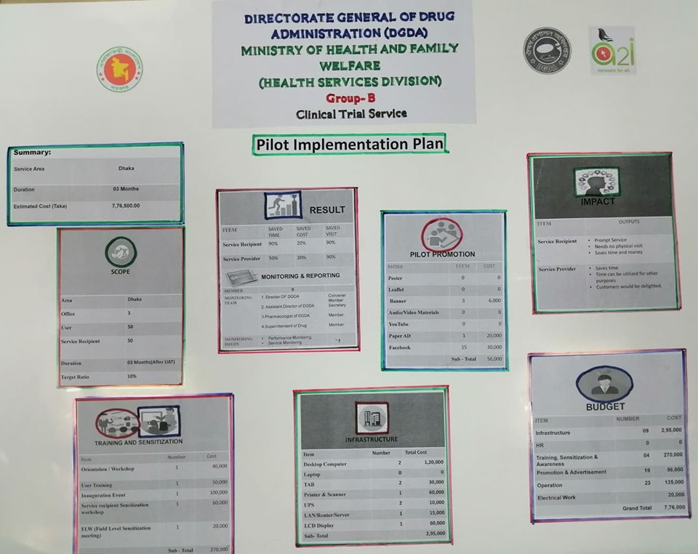

Fig. No.: 8

### Software Development Budget

|  |  |  |  |  |  |
| --- | --- | --- | --- | --- | --- |
| **Budget for Ministry of Health & Family Welfare (Health Service Division) Group Name: B** | | | | | |
|
| **Organization Name: Directorate General of Drug Administration** | | | | | |
| **Service/Component Name: Clinical Trial Service** | | | | | |
| No. of Module : 4 |  | Category: Medium | |  |  |
| **Cost Center** | **Cost Item** | **Resource Unit** | **(Man Day)** | **Unit Cost** | **Total Cost** |
| **System Requirement Study** |  |  | **35** |  |  |
|  | Project Manager | 1 | 13 | 7000 | 91,000 |
|  | Business Analyst | 1 | 23 | 5000 | 116,667 |
|  | System Analyst | 1 | 12 | 5500 | 64,167 |
|  | Technical Document Writer | 1 | 23 | 3000 | 70,000 |
|  | Survier | 0 | 35 | 2000 | - |
|  | Technical Assistant | 1 | 12 | 2000 | 23,333 |
| **Sub-Total** |  |  |  |  | **365,167** |
| **System Analysis & Design** |  |  | **35** |  |  |
|  | Project Manager | 1 | 11.667 | 7000 | 81,667 |
|  | Business Analyst | 1 | 18 | 5000 | 87,500 |
|  | System Analyst | 1 | 23 | 5500 | 128,333 |
|  | Software Architecht | 1 | 9 | 7500 | 65,625 |
|  | Database Administrator/Designer | 1 | 12 | 5000 | 58,333 |
|  | Technical Document Writer | 1 | 23 | 3000 | 70,000 |
|  | UI Designer | 1 | 12 | 3500 | 40,833 |
|  | UX Expert | 1 | 12 | 4500 | 52,500 |
|  | Technical Assistant | 1 | 18 | 2000 | 35,000 |
| Sub-Total |  |  |  |  | **619,792** |
| **System Development** |  |  | **150** |  |  |
|  | Project Manager | 1 | 50 | 7000 | 350,000 |
|  | Sr.Developer/Programmer | 2 | 100 | 5000 | 1,000,000 |
|  | Developer/Programmer | 3 | 150 | 4500 | 2,025,000 |
|  | Sr.Mobile Apps Developer /Programmer | 2 | 100 | 4500 | 900,000 |
|  | Mobile Apps Developer | 2 | 150 | 3500 | 1,050,000 |
|  | System Analyst | 1 | 50 | 5500 | 275,000 |
|  | Sofware Architecht | 1 | 15 | 7500 | 112,500 |
|  | Database Administrator/Designer | 1 | 38 | 5000 | 187,500 |
|  | Technical Document Writer | 1 | 75 | 3000 | 225,000 |
|  | UI Designer | 1 | 50 | 2500 | 125,000 |
|  | UX Expert | 1 | 38 | 3500 | 131,250 |
|  | QA Expert | 1 | 75 | 4500 | 337,500 |
|  | Technical Assistant | 1 | 50 | 2000 | 100,000 |
|  |  |  |  |  | **6,818,750** |
| **Integration** |  |  | **15** |  |  |
|  | Project Manager | 1 | 5 | 7000 | 35,000 |
|  | Sr.Developer/Programmer | 1 | 5 | 5000 | 25,000 |
|  | Developer/Programmer | 1 | 8 | 4500 | 33,750 |
|  | Mobile Apps. Developer /Programmer | 1 | 5 | 4500 | 22,500 |
|  | System Analyst | 1 | 4 | 5500 | 20,625 |
|  | Database Administrator | 1 | 4 | 5000 | 18,750 |
|  | Technical Document Writer | 1 | 8 | 3000 | 22,500 |
|  | Interoperability Expert | 1 | 15 | 5500 | 82,500 |
|  | Security Expert | 1 | 15 | 5500 | 82,500 |
|  | QA Expert | 1 | 5 | 4500 | 22,500 |
|  | Technical Assistant | 0 | 5 | 2000 | - |
|  |  |  |  |  | 365,625 |
| **Hosting** |  |  | **20** |  |  |
|  | Project Manager | 1 | 5 | 7000 | 35,000 |
|  | Developer/Programmer | 1 | 5 | 5000 | 25,000 |
|  | Mobile Apps Developer/Programmer | 1 | 5 | 4500 | 22,500 |
|  | System Analyst | 1 | 4 | 5500 | 22,000 |
|  | System Administrator | 1 | 20 | 5000 | 100,000 |
|  | Security Expert | 1 | 20 | 5500 | 110,000 |
|  | Technical Document Writer | 1 | 4 | 3000 | 12,000 |
|  | QA Expert | 1 | 10 | 4500 | 45,000 |
|  | Technical Assistant | 0 | 7 | 2000 | - |
|  |  |  |  |  | 371,500 |
| **User Acceptance Testing (UAT)** |  |  | **25** |  |  |
|  | Project Manager | 1 | 6 | 7000 | 43,750 |
|  | Sr.Developer/Programmer | 1 | 8 | 5000 | 41,667 |
|  | Developer/Programmer | 0 | 8 | 4500 | - |
|  | Mobile Apps. Developer/Programmer | 1 | 8 | 4500 | 37,500 |
|  | System Analyst | 1 | 6 | 5500 | 34,375 |
|  | System Adminstrator | 1 | 5 | 7500 | 37,500 |
|  | Technical Document Writer | 1 | 13 | 3000 | 37,500 |
|  | QA Expert | 1 | 17 | 4500 | 75,000 |
|  | Technical Assistant | 0 | 13 | 2000 | - |
|  |  |  |  |  | 307,292 |
| **User Training & Deployment** |  |  | **25** |  |  |
|  | Project Manager | 1 | 6 | 7000 | 43,750 |
|  | Technical Document Writer | 1 | 8 | 3000 | 25,000 |
|  | Training Expert | 1 | 25 | 4000 | 100,000 |
|  | Technical Assistant | 1 | 8 | 2000 | 16,667 |
|  |  |  |  |  | 185,417 |
| Sub-Total |  | **Total Developmnent Cost** | | | **9,033,542** |
| **Maintenance support** |  | 3 | Year |  | **4,065,093.75** |
| **Reinversable Cost** |  |  |  |  | 903,354 |
| **Sub-Total** |  |  |  |  | **14,001,990** |
| **Add: VAT& Taxes** |  |  |  |  | 700,099 |
| **Grand Total** |  |  |  |  | **14,702,089** |

### Pilot Implementation Budget

|  |  |  |  |  |  |
| --- | --- | --- | --- | --- | --- |
| **Piloting Budget for Ministry of Health and Family welfare** | | | | | |
|
|  | Organization Name: | Directorate General of Drug Administration | | | |
|  | Service Name: | Clinical Trial | | | |
|  | Group: | B | | | |
|  | No. of Module | 4 | | | |
|  | | | | | |
| **SL** | **Cost Center** | **Cost Item** | **UNIT** | **Unit Cost** | **Total Cost** |
| 1 | **Infrastructure** |  |  |  |  |
|  |  | Desktop Computer/PC | 2 | 60000 | 120,000.00 |
|  |  | Laptop | 0 | 80000 | - |
|  |  | TAB | 2 | 15000 | 30,000.00 |
|  |  | Mobile | 0 | 30000 | - |
|  |  | LAN /Router /LAN Server | 1 | 15000 | 15,000.00 |
|  |  | Printer (Network)& Scanner | 1 | 60000 | 60,000.00 |
|  |  | UPS | 2 | 5000 | 10,000.00 |
|  |  | Internet Line from BTCL | 0 | 50000 | - |
|  |  | LCD Display for Dashboard | 1 | 60000 | 60,000.00 |
|  | **Sub-Total** |  |  |  | **295,000.00** |
| 2 | **HR Outsource for Piloting** |  |  |  |  |
|  |  | Data Entry Operator | 0 | 15000 | - |
|  |  | Data Validation | 0 | 10000 | - |
|  |  | IT Excutive for System Admin | 0 | 20000 | - |
|  | **Sub-Total** |  |  |  | **-** |
| 3 | **Sensitization & Training** |  |  |  |  |
|  |  | Orientation workshop | 1 | 40000 | 40,000.00 |
|  |  | User Training | 1 | 50000 | 50,000.00 |
|  |  | Inaguration Event | 1 | 100,000 | 100,000.00 |
|  |  | Service receipient Senstization workshop | 1 | 60000 | 60,000.00 |
|  |  | FLW (Field Level Sesitization meeting) | 1 | 20000 | 20,000.00 |
|  | **Sub-Total** |  |  |  | **270,000.00** |
| 4 | **Promotion & Advertisement** |  |  |  |  |
|  |  | TV AD | 0 | 100000 | - |
|  |  | Local TV AD | 0 | 50000 | - |
|  |  | Billboard | 0 | 50000 | - |
|  |  | Poster | 0 | 15 | - |
|  |  | Leaflet | 0 | 10 | - |
|  |  | Banner | 3 | 2000 | 6,000.00 |
|  |  | Audio/Vidoe Materials | 0 | 50000 | - |
|  |  | Digital Display | 0 | 200000 | - |
|  |  | Youtube | 0 | 10000 | - |
|  |  | IVR | 0 | 50000 | - |
|  |  | USSD | 0 | 100000 | - |
|  |  | Paper AD | 1 | 20000 | 20,000.00 |
|  |  | Voice Message | 0 | 10 | - |
|  |  | SMS | 0 | 0.5 | - |
|  |  | Facebook | 15 | 2000 | 30,000.00 |
|  | **Sub-Total** |  |  |  | 56,000.00 |
| 5 | **Operation** |  |  |  |  |
|  |  | System Generetaed SMS or Bulk SMS | 30000 | 0.25 | 7,500.00 |
|  |  | Stationaries (Monthly) | 3 | 5000 | 15,000.00 |
|  |  | Hardware maintenance (Monthly) | 15 | 5000 | 75,000.00 |
|  |  | Internet Monthly (Monthly) | 3 | 1000 | 3,000.00 |
|  |  | Others | 1 | 34500 | 34,500.00 |
|  | **Sub-Total** |  |  |  | 135,000.00 |
| 6 | **Electrical Work** |  | 1 | 20000 | 20,000.00 |
| 11 | **Grand Total** |  |  |  | **776,000.00** |

## Conclusion

Ministry of Health and family welfare has the mission of ensuring the best Government online Digital Service s to make the life of citizens comfortable. Planned digitization implies the broad use of computers, and embodies the modern philosophy of effective and useful use of Information & Communication Technology in terms of implementing the promises in education, health and poverty reduction under “Digital Bangladesh” initiative. This will include all classes of people does not discriminate people in terms of technology.

In view of the above, Vendor has to design, develop, implement, maintain a Single Sign-on web & mobile Apps based solution for Digital Service s for Ministry of Agriculture. Obviously, the proposed technical proposal has to reflect the visualization, deep level understanding of the processes, system requirement/sizing, development platform, Quality Assurance (QA) plan including capability of adopting future technologies.

**Abbreviations**:

|  |  |  |
| --- | --- | --- |
| DG | : | Director General |
| DD | : | Deputy Director |
| AD | : | Assistant Director |
| SSA | : | Senior Systems Analyst |
| SA | : | Systems Analyst/ Systems Administrator |
| SME | : | Senior Maintenance Engineer |
| AP | : | Assistant Programmer |
| DBA | : | Database Administrator |
| IFB | : | Islamic Foundation of Bangladesh |
| ICT | : | Information and Communication Technology |
| ID | : | Identification |
| IVR | : | Interactive Voice Response |
| NID | : | National Identification |
| PD | : | Project Director |
| SMS | : | Short Message Service |
| TCV | : | Time, Cost & Visit |
| UDC | : | Union Digital Center |
| 999 | : | National Emergency Service |
| 333 | : | National Information Call Center |
| CC | : | Call Center |
| NDC | : | National Data Center |
| BCC | : | Bangladesh Computer Council |
| UAT | : | User Acceptance Test |
| TOR | : | Terms of Reference |
| SRS | : | System Requirement Specification |
| SDD | : | System Design Document |
| SLA | : | Service Level Agreement |
| USSD | : | Unstructured Supplementary Service Data |